**Detailed Description for the Freight Layers**

**Data source, collection and analysis method**

Except the AADT Truck percentage, WSDOT Freight and Goods, and AADT layers, all the rest data layers under “Freight” Tab were developed based on the truck GPS data.

The truck GPS data was collected for one year (September 2010 to September 2011) from about 6,000 GPS-equipped trucks per day traveling on roads throughout Washington State. The commercial in-vehicle GPS devices report, via cellular technology, both at preset intervals (every 10 to 15 minutes) and when the trucks stop. The resulting GPS data set includes reads for individual truck’s longitude and latitude, the truck’s ID (scrambled for privacy), spot (instantaneous) speeds, and a date and time stamp.

Utilizing geographical information system (GIS) techniques, the state’s roadway network was partitioned into individual segments at following locations: access ramps, changes in posted speed limit, county boundaries, urban/rural area boundaries, and signalized intersection. Then the truck GPS data was assigned to these segments to evaluate the roadway performance. The performance analysis was only conducted for the segments with enough GPS truck data reads for a valid analysis—a minimum of a 200 trucks per segment. Three performance measures were adopted:

* **Average Speed:** this measure calculates the average speed for trucks based on the truck spot speeds collected over each freeway segment.
* **Frequency of truck speed falling below 60 percent of posted speed:** this measure calculates the percentage of truck spot speeds falling below 60 percent of the posted speed limit. 60 percent of posted speed was selected as the threshold because it is used in WSDOT congestion report as the speed threshold for evaluating whether the freeways are experiencing severe congestion.
* **Travel Reliability**: The reliability evaluation criteria examine whether the travel conditions during a given time period (in the central Puget Sound region) or a given day (in the non-Puget Sound areas of the state) are reliable, given the speed distribution and a statistical fitting process. Generally speaking, if the speed distribution has two speed “humps” and is bimodal (such as in Figure 1a), then the travel condition is considered unreliable. Otherwise, the travel condition is unimodal and is considered reliable with one average speed (as in Figure 1b).

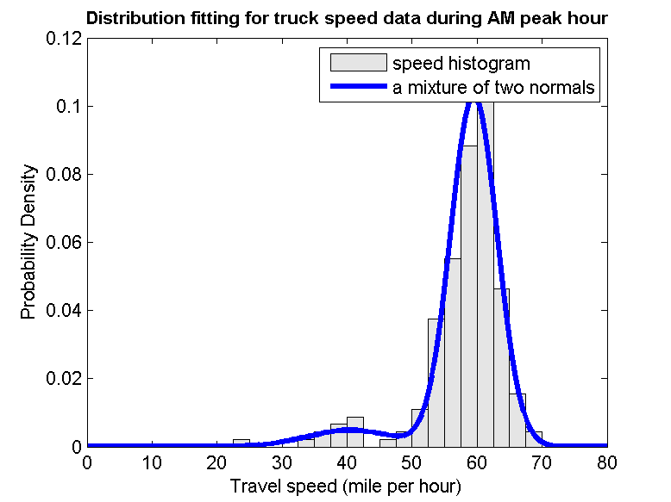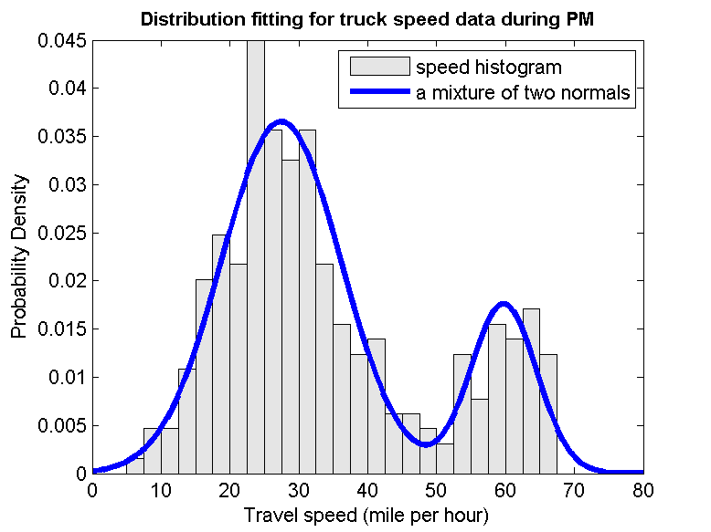

**Figure 1: Speed Distribution: (a) speed distribution with a bimodal feature (b) speed distribution with a unimodal feature.**

The evaluation process separates Washington State into Puget Sound area and the rest of the state (referred as statewide). That is because the methodology adopted for Puget Sound and statewide is different. For Puget Sound area, the GPS data was subdivide into three time periods (AM, Midday, and PM); while for statewide, daytime time was used for analysis without differentiating time periods.

Those three measures are used to identify and rank truck bottlenecks in Washington State. Roadway segments with unreliable travel condition for trucks are perceived as truck bottlenecks. The bottlenecks are separated into Puget Sound bottlenecks and statewide bottlenecks, and then further subdivided by Freight Corridor Classifications. The classification is based on the average annual gross tonnage carried by the roadway:

* T-1 corridor (more than 10 million tons per year)
* T-2 (4 million to 10 million tons per year)
* T-3 (300,000 to 4 million tons per year)
* T-4 (100,000 to 300,000 tons per year)
* T-5 (at least 20,000 tons in 60 days)

Truck bottlenecks are ranked based on following criteria:

1. Rank PSRC bottlenecks by total number of unreliable performance periods (throw out nighttime period); Rank statewide bottlenecks with all those segments with unreliable performance at top.
2. Rank bottlenecks by percentage of truck travel speed falling below 60 percent of posted speed.

Bottlenecks are only compared within the same freight roadway (FGTS) classification, and a separate ranking list is developed for each category.

*The data collection is an on-going process and these layers are updated regularly when new GPS data becomes available. Please check* [*http://www.wsdot.wa.gov/NR/rdonlyres/B7A5D60C-BF99-412F-9444-BA513768DC93/0/TPMFinalreportver2_17June2011.pdf*](http://www.wsdot.wa.gov/NR/rdonlyres/B7A5D60C-BF99-412F-9444-BA513768DC93/0/TPMFinalreportver2_17June2011.pdf) *for detailed information about Truck Performance Measure Project.*

**Definition and Symbology of Freight Data Layers**

**AADT Truck percentage:** this layer displays the truck percentage of Annual Average Daily Traffic volumes in 2010 collected by WSDOT Statewide Travel and Collision Data Office for the State Highway System.

Truck percentage is represented with graduated colors on the map and grouped into three classes: truck percentage under 10%, between 10% to 20%, and truck percentage over 20%.

**Average Speed:** this layer displays the average truck speed calculated from truck GPS data. Average speed is calculated based on the truck spot speeds collected over each freeway segments from 6 am to 7 pm during weekdays (night data collected from 7 pm to 6 am were excluded for analysis).

Average speed is represented with graduated colors on the map and grouped into seven classes. The class is equal sized and each represents a range of 10 mph.

**Bottleneck Puget Sound:** this layer displays the truck bottlenecks identified in PSRC area. Sub layers were created for the 20 worst bottlenecks and the other bottlenecks for each classification of FGTS freight corridors. The bottlenecks are subdivided by FGTS classification, and ranked based the following criteria: 1) rank by number of unreliable performance periods (throw out nighttime period). 2) rank by “percentage of truck speed falling below 60% of posted speed”.

Bottlenecks are represented by two colors on the map. The worst 20 bottlenecks for each Freight corridor classification are represented by red, and the other bottlenecks are represented by blue.

**Bottleneck Statewide:** this layer displays the truck bottlenecks identified in other areas of the state. Sub layers were created for the 20 worst bottlenecks for T-1 and T-2 FGTS freight corridors. The bottlenecks are subdivided by FGTS classification, and ranked based the following criteria: 1) rank with all those with unreliable performance at the top; 2) rank by “percentage of truck speed falling below 60% of posted speed”.

Bottlenecks are represented by red on the map. Only the worst 20 bottlenecks for each Freight corridor classification are shown in the application.

**Reliability Puget Sound:** this layer displays the truck travel reliability during three different time periods (AM, midday, and PM) in PSRC. AM time period is 6 am – 9 am; Midday time period is 9 am – 3 pm; and PM time period is 3 pm – 7 pm. The travel reliability was evaluated based on truck speed distribution. If the truck speed distribution is unimodal and only has one peak (figure 1a), the roadway segment is reliable; if the truck speed distribution is bimodal and has two peaks (figure 1b), the roadway segment is unreliable.



**Figure 1: Speed Distribution: (a) speed distribution with a bimodal feature (b) speed distribution with a unimodal feature.**

Reliability is represented by two colors on the map. “Unreliable” is represented by red, and “Reliable” is represented by green.

**Reliability Statewide:** this layer displays the truck travel reliability in other areas of the state. The travel reliability was evaluated for the 13-hour time period (6 am to 7 pm in weekdays). Due to difference in time periods adopted for reliability evaluation, the **Reliability Puget Sound** data layer is not comparable to **Reliability Statewide** data layer.

Reliability is represented by two colors on the map. “Unreliable” is represented by red, and “Reliable” is represented by green.

**Severe Speed Threshold:** this layer displays the percentage of truck speed falling below 60 percent of the posted speed. Night data (7pm to 6 am) was excluded to calculate this measure.

Severe Speed Threshold is represented with graduated colors and grouped into five classes. The class if equal sized and each represents a range of 0.2.

**WSDOT Freight and Goods:** this layer displays the classification of state highways, county roads, and city streets according to the average annual gross tonnage they carry in 2011. The roadways are classified into six different categories:

* T-1 (more than 10 million tons per year)
* T-2 (4 million to 10 million tons per year)
* T-3 (300,000 to 4 million tons per year)
* T-4 (100,000 to 300,000 tons per year)
* T-5 (at least 20,000 tons in 60 days)

Such classification is the same as FGTS classification system adopted by FMSIB.

FGTS corridors are represented with graduated colors and each category is represented by a unique color.

**AADT:** this layer displays Annual Average Daily Traffic volumes collected and maintained by WSDOT Statewide Travel & Collision Data Office for the State Highway System.

AADT is represented with graduated symbol size and color. AADT on different types of highways (US, IS, SR) is represented by varying line thickness and the volume of AADT is represented by varying the line color.